1. video explaining the complete software (Screen recording with audio).

<https://drive.google.com/file/d/19UZeik0WUr9vWr8yPvjsdB63Igv8lgu6/view?usp>=sharing

**3**

**System Design**

**Action**

**Controller**

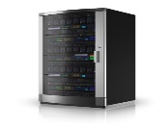

**JSP View**

**Action**



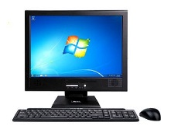



 

**Librarian**



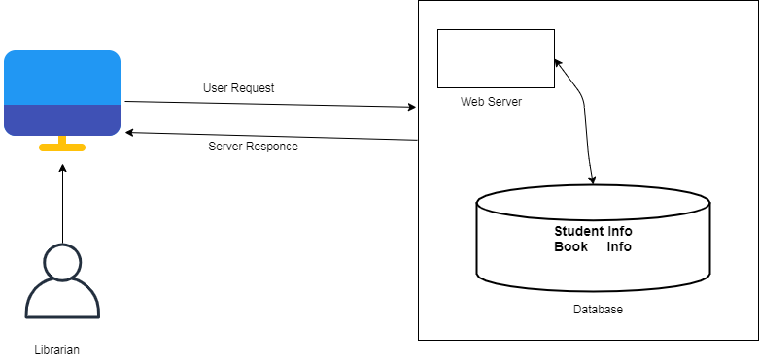

**Component Diagram**

**LMS Database**

**Book**

**Package Name**

**Search**

**Transaction**

**Student**



**Deployment Diagram**

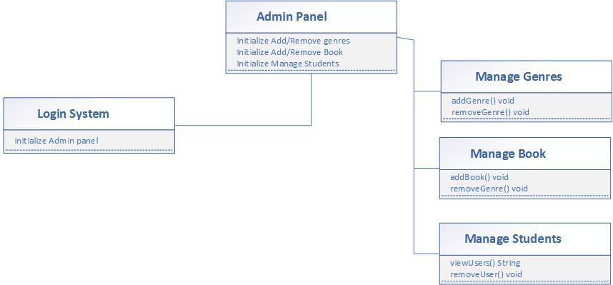

**(UML) Activity Diagram**

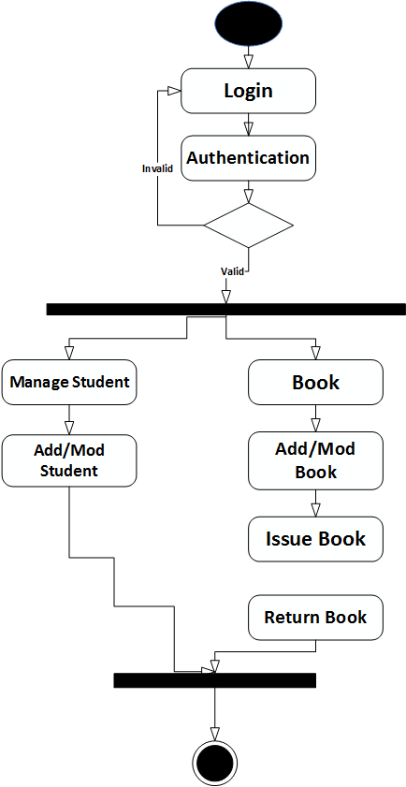

**CLASS Diagram**

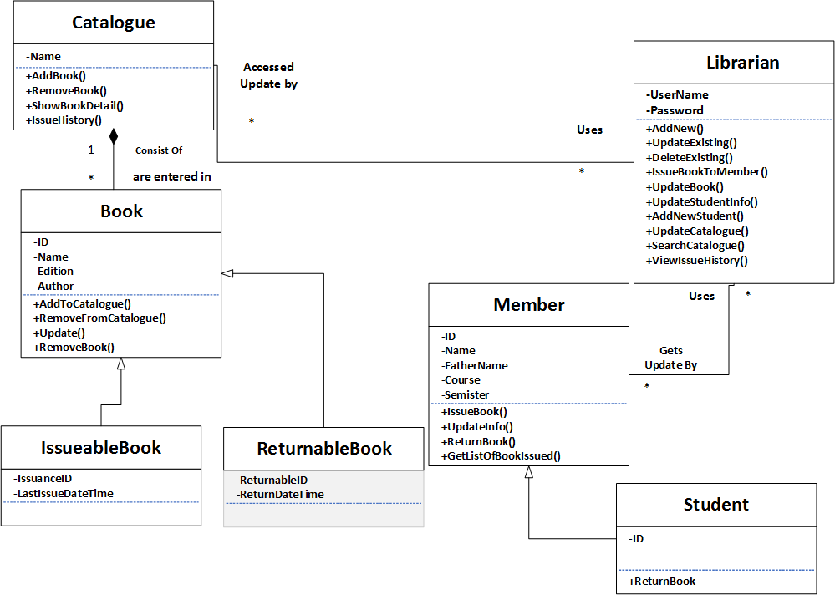

**Software Architecture**

**Librarian**